Part 1 Report:

First, I put all data into 15 mins time intervals. I used the scatter plot to represent the date. The plot does not make too much sense to me since all the data points are clustered together, not able to extract meaningful information from the plot. I decide to do more analysis without considering date information.

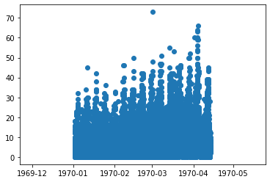

Second, I add in another column into dataset, time column, regardless of the date information. I utilized simple line plot to demonstrate the total counts of each 15 minutes in a day. The plot shows two peaks around 11am to 12pm and also 10pm to 12am which means the website has maximum clicks during these two periods of time.

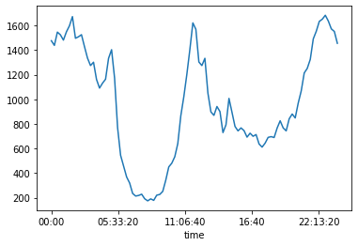

Third, I add in another column, weekday column into data frame, trying to analyze the total click trends between weekdays. A simple line plot is also utilized here to show the trend. The maximum clicks happen at Saturday and start to decline in Sunday. Monday and Tuesday have the least number of clicks.

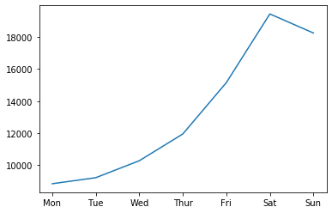

At last, I did the analysis by month and also by the 15 minutes time intervals within each month. The plot agrees with the second plot showing two peaks in a day and also showing the declining trend from Jan to Apr.

